Half Adder
library IEEE;
use IEEE.STD_LOGIC_1164.ALL;

-- Uncomment the following library declaration if using
-- arithmetic functions with Signed or Unsigned values
--use IEEE.NUMERIC_STD.ALL;

-- Uncomment the following library declaration if instantiating
-- any Xilinx primitives in this code.
--library UNISIM;
--use UNISIM.VComponents.all;

entity adder is
Port ( a : in STD_LOGIC;
b : in STD_LOGIC;
s : out STD_LOGIC;
c : out STD_LOGIC);
end adder;

architecture Behavioral of adder is

begin
s<=a xor b;
c<=a and b;

end Behavioral;

LIBRARY ieee;
USE ieee.std_logic_1164.ALL;

-- Uncomment the following library declaration if using
-- arithmetic functions with Signed or Unsigned values
--USE ieee.numeric_std.ALL;

ENTITY hadder IS
END hadder;

ARCHITECTURE behavior OF hadder IS

-- Component Declaration for the Unit Under Test (UUT)

COMPONENT adder
PORT(
a : IN std_logic;
b : IN std_logic;
s : OUT std_logic;
c : OUT std_logic
);
END COMPONENT;

--Inputs
signal a : std_logic := '0';
signal b : std_logic := '0';

--Outputs
signal s : std_logic;
signal c : std_logic;
-- No clocks detected in port list. Replace <clock> below with
-- appropriate port name

--constant <clock>_period : time := 10 ns;

BEGIN

-- Instantiate the Unit Under Test (UUT)
uut: adder PORT MAP (
a => a,
b => b,
s => s,
c => c
);

-- Clock process definitions
-- <clock>_process :process
-- begin
-- <clock> <= '0';
-- wait for <clock>_period/2;
-- <clock> <= '1';
-- wait for <clock>_period/2;
-- end process;
--

-- Stimulus process
stim_proc: process
begin
a<='0';
b<='0';
-- hold reset state for 100 ns.
wait for 100 ns;
a<='0';
b<='1';
-- hold reset state for 100 ns.
wait for 100 ns;
a<='1';
b<='0';
-- hold reset state for 100 ns.
wait for 100 ns;
a<='1';
b<='1';
-- hold reset state for 100 ns.
wait for 100 ns;

--wait for <clock>_period*10;

-- insert stimulus here

wait;
end process;

END;

Full Adder

library IEEE;
use IEEE.STD_LOGIC_1164.ALL;

-- Uncomment the following library declaration if using
-- arithmetic functions with Signed or Unsigned values
--use IEEE.NUMERIC_STD.ALL;

-- Uncomment the following library declaration if instantiating
-- any Xilinx primitives in this code.
--library UNISIM;
--use UNISIM.VComponents.all;

entity fulladder is
Port ( x : in STD_LOGIC;
y : in STD_LOGIC;
z : in STD_LOGIC;
s : out STD_LOGIC;
c : out STD_LOGIC);
end fulladder;

architecture Behavioral of fulladder is

begin
s<=(x xor y)xor z;
c<=((x xor y) and z) or (x and z);

end Behavioral;

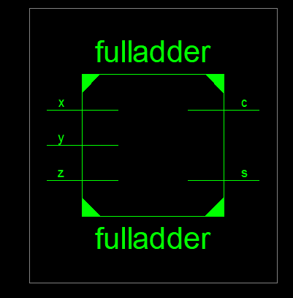

LIBRARY ieee;
USE ieee.std_logic_1164.ALL;

-- Uncomment the following library declaration if using
-- arithmetic functions with Signed or Unsigned values
--USE ieee.numeric_std.ALL;

ENTITY fadder IS
END fadder;

ARCHITECTURE behavior OF fadder IS

-- Component Declaration for the Unit Under Test (UUT)

COMPONENT fulladder
PORT(
x : IN std_logic;
y : IN std_logic;
z : IN std_logic;
s : OUT std_logic;
c : OUT std_logic
);
END COMPONENT;

--Inputs
signal x : std_logic := '0';
signal y : std_logic := '0';
signal z : std_logic := '0';

--Outputs
signal s : std_logic;
signal c : std_logic;
-- No clocks detected in port list. Replace <clock> below with
-- appropriate port name

--constant <clock>_period : time := 10 ns;

BEGIN

-- Instantiate the Unit Under Test (UUT)
uut: fulladder PORT MAP (
x => x,
y => y,
z => z,
s => s,
c => c
);

-- Clock process definitions
-- <clock>_process :process
-- begin
-- <clock> <= '0';
-- wait for <clock>_period/2;
-- <clock> <= '1';
-- wait for <clock>_period/2;
-- end process;
--

-- Stimulus process
stim_proc: process
begin
x<='0';
y<='0';
z<='0';
-- hold reset state for 100 ns.
wait for 100 ns;
x<='0';
y<='1';
z<='0';
-- hold reset state for 100 ns.
wait for 100 ns;
x<='0';
y<='0';
z<='1';
-- hold reset state for 100 ns.
wait for 100 ns;
x<='0';
y<='1';
z<='1';
-- hold reset state for 100 ns.
wait for 100 ns;
x<='1';
y<='0';
z<='0';
-- hold reset state for 100 ns.
wait for 100 ns;
x<='1';
y<='0';
z<='1';
-- hold reset state for 100 ns.
wait for 100 ns;
x<='1';
y<='1';
z<='0';
-- hold reset state for 100 ns.
wait for 100 ns;
x<='1';
y<='1';
z<='1';
-- hold reset state for 100 ns.
wait for 100 ns;

--wait for <clock>_period*10;

-- insert stimulus here

wait;
end process;

END;
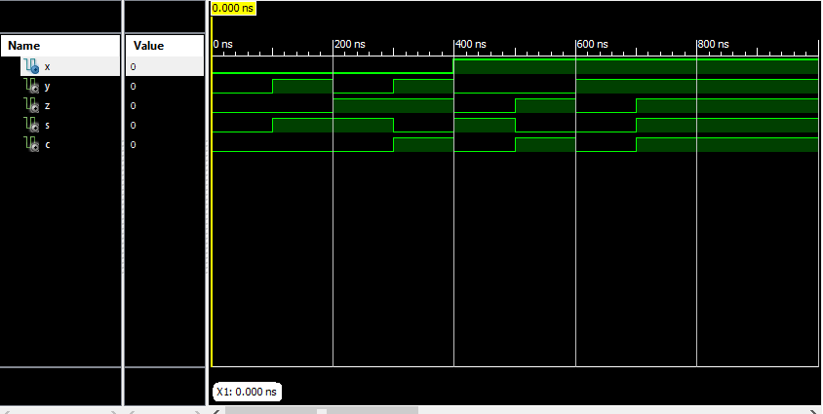
net "x" loc = "p101";
net"y"loc="p100";
net"z"loc="p97";
net"s"loc="p171";
net"c"loc="p172";

* Final Report *
=========================================================================
Final Results
RTL Top Level Output File Name : fulladder.ngr
Top Level Output File Name : fulladder
Output Format : NGC
Optimization Goal : Speed
Keep Hierarchy : No

Design Statistics
# IOs : 5

Cell Usage :
# BELS : 2
# LUT3 : 2
# IO Buffers : 5
# IBUF : 3
# OBUF : 2
=========================================================================

Device utilization summary:
---------------------------

Selected Device : 3s400pq208-4

Number of Slices: 1 out of 3584 0%
Number of 4 input LUTs: 2 out of 7168 0%
Number of IOs: 5
Number of bonded IOBs: 5 out of 141 3%

---------------------------
Partition Resource Summary:
---------------------------

No Partitions were found in this design.

---------------------------

=========================================================================
TIMING REPORT

NOTE: THESE TIMING NUMBERS ARE ONLY A SYNTHESIS ESTIMATE.
FOR ACCURATE TIMING INFORMATION PLEASE REFER TO THE TRACE REPORT
GENERATED AFTER PLACE-and-ROUTE.

Clock Information:
------------------
No clock signals found in this design

Asynchronous Control Signals Information:
----------------------------------------
No asynchronous control signals found in this design

Timing Summary:
---------------
Speed Grade: -4

Minimum period: No path found
Minimum input arrival time before clock: No path found
Maximum output required time after clock: No path found
Maximum combinational path delay: 9.033ns

Timing Detail:
--------------
All values displayed in nanoseconds (ns)

=========================================================================
Timing constraint: Default path analysis
Total number of paths / destination ports: 6 / 2
-------------------------------------------------------------------------
Delay: 9.033ns (Levels of Logic = 3)
Source: z (PAD)
Destination: c (PAD)

Data Path: z to c
Gate Net
Cell:in->out fanout Delay Delay Logical Name (Net Name)
---------------------------------------- ------------
IBUF:I->O 2 0.821 1.216 z_IBUF (z_IBUF)
LUT3:I0->O 1 0.551 0.801 c1 (c_OBUF)
OBUF:I->O 5.644 c_OBUF (c)
----------------------------------------
Total 9.033ns (7.016ns logic, 2.017ns route)
(77.7% logic, 22.3% route)

=========================================================================

Total REAL time to Xst completion: 4.00 secs
Total CPU time to Xst completion: 3.66 secs

-->

Total memory usage is 4493176 kilobytes

Number of errors : 0 ( 0 filtered)
Number of warnings : 0 ( 0 filtered)
Number of infos : 0 ( 0 filtered)

